New Mexico School for the Arts

Charter Five-Year Facility Master Plan/ Ed Specification Dated 2018-2023

“Talent never exists by itself. Talent only exists because of opportunity.”
- Joel Fan

Approved by NMSA Governance Council on February 13, 2019

1

Leased Facility is located at 275 East Alameda, Santa Fe, NM 87501.
Lease ends July 31, 2019. School will be relocating to its new home at 500 Montezuma July, 2020.

Charter Approved: September 13, 2008 First Charter Renewal: January 2014
Second Charter Renewal Application: Approved December 2018
Charter Approved for 300 students.
First Year of Operation: August 2010

School Contact: Eric Crites, Head of School Phone: (505) 310-4194 x105
Art Institute Contact: Cindy Montoya, President Phone: (505) 216-7888 x 7 (505) 795 8202 cellular

Acknowledgements:
NMSA-Charter School Governing Council
Bill Beacham, Chair Michael Kaplan, Vice Chair
Greg Hunt, Treasurer Paula Tackett, Secretary
Cynthia Nava, Member Neil Heighberger, Member

Head of School Business Manager
Eric Crites Liza Romero

Assistant Principal Assistant Business Manager
Chelamia Quintana Gayle McGuiness

Registrar & Operations IT Manager
Cecile Hemez Ruben Desangles

New Mexico School for the Arts- Art Institute
Cindy Montoya, President

Table of Contents

INTRODUCTION

- GOALS/MISSION
    - Mission and Statement of Purpose
    - General Educational Philosophy
    - Serving the Community
    - Process
    - Data Gathering and Analysis
    - Authority and Facility Decision Making

EXISTING AND PROJECTED CONDITIONS
    - Programs and Delivery Methods
    - Anticipated Changes in Programs
  - Enrollment
    - Current, Historic and Projected Enrollment
    - Enrollment History by Arts Program
    - Student Origination
    - Classroom Loads/Sizes
    - Classroom Needs
  - Site and Facilities
    - Current Location
    - Current Site
    - Facility
    - Facility Evaluation
    - Statewide Adequacy Standards
  - Utilization and Capacity
    - Utilization: Identify special factors that influence facility use
    - Capacity
  - Technology - Overview of Tech. plan and needed equipment
  - Energy Management

FACILITY REQUIREMENTS
3.1.1. Facility Goals and Concepts
    - Space Requirements
    - Site Requirements

3.2.2 Space Requirements
3.3 Implementation of Space Needs

CAPITAL PLAN
    - Capital Funding
    - Capital Needs
    - Implementation Strategy

MASTER PLAN SUPPORT MATERIAL
    - Data Table
    - Site Plan
    - Floor Plan
    - Facility Inventory - room use and square footage of each room
    - Photographs (min. one exterior and one interior)
    - Facility Evaluation
    - FAD forms updated
    - Detailed Space and Room Requirements (Ed Spec), if applicable
    - Capital Improvement Plan (if available) Summary of Priorities

APPENDICES B-F

Introduction

- Students, parents and teachers in New Mexico expressed the need to keep creative youth in state to further their artistic abilities. Why send our talent away when we can build opportunities at home? Why import talent from other states in the arts economies when we can cultivate it here in an arts-based high school?
- Artists, educators, philanthropists and policy makers responded to this need, proposing the creation of NMSA. They were supported by hundreds of New Mexico citizens.
- In 2008, the Legislature passed and the Governor signed a bill establishing the first legislatively-created public arts school in the State’s history—New Mexico School for the Arts. Over 100 legislators voted to establish the legislation for the School.
- The Public Education Commission of New Mexico (PEC) approved the School’s charter application on September 13, 2008.
- The charter was renewed for the first time in January 2014.
- A second charter renewal application was approved in December of 2018.

NMSA opened its doors in the leased St. Francis Cathedral School on August 16, 2010, with 138 students from across New Mexico studying core and advanced academics coupled with mastery level Dance, Music, Theater or Visual Arts. Its location, in Santa Fe, affords students walking- distance access to Santa Fe’s finest museums, performing arts spaces, and cultural institutions to further their learning in the arts.

In August of 2018, NMSA will open its doors for the ninth time with an enrollment of 221 students. NMSA is limited to 221 students due to the size of the current location.
The Public School Capital Outlay Council (PSCOC) and the Public School Facilities Authority (PSFA) require that all New Mexico public charter schools have a five-year Facility Master Plan and Educational Specifications (FMP/EdSpec) as a prerequisite for eligibility to receive public school capital outlay fund assistance. It requires a document to

guide capital planning decisions that support the School’s educational mission and meet minimum state adequacy standards.

NMSA is established under the New Mexico School for the Arts Act (Chapter 22, Article 15F NMSA 1978) as a statewide residential
state-chartered high school for grades nine through twelve. For New Mexico students who have demonstrated artistic abilities and potential, NMSA provides an educational opportunity to pursue a career in the arts and a strong academic program that leads to a New Mexico diploma of excellence.
The School is currently housed in a leased facility, Cathedral School, on the corner of Alameda and Paseo de Peralta, in Santa Fe. Its current lease extension ends in July 2019. It has an option to extend through July 2020.

This report follows the format required by the Public School Facilities Authority (PSFA) and is comprised of the following sections:
  - Introduction
  - Section 1. Goals/Mission
  - Section 2. Existing and Projected Conditions
  - Section 3. Facility Requirements (Ed Spec)
  - Section 4. Capital Plan
  - Section 5. Master Plan Support Material
  - Appendices

As part of the process in developing the New Mexico School for the Arts Facilities Master Plan/Educational Specification, the Statewide Adequacy Standards NMAC 6.27.30 and Charter-Alternative School Statewide Adequacy Standard Variance table was reviewed when creating the first plan.

1. GOALS/MISSION

Mission and Statement of Purpose Mission
NMSA provides access to a rigorous mastery arts and academic high school education
for youth with passion and aptitude in the arts, leading to post-secondary learning, careers in the arts, and lives that contribute to society.

Statement of Purpose
NMSA’s purpose is to provide the highest standards of excellence in preparing New Mexico’s artistically talented students to compete in the national arena for
post-secondary and/or professional careers in the arts, regardless of home location. NMSA offers pre-professional instruction in the performing and visual arts along with rigorous academics leading to a high school diploma.

General Educational Philosophy
As explained in the School’s Charter, the focus on “art, heart and smart” will allow the School to achieve its mission:

Art -- First, the School will focus on artistic studies as well as introduce the students to the wider arts market and industries, since many art high school graduates nationwide pursue careers in the arts industry, not as practicing artists. Many students learn in non-traditional ways that have drawn them to their artistic interest. When alignment happens between arts and education for passionate art students, the students excel. Art schools are natural integration schools. In fact the term “magnet school” was first used to describe the phenomenon that occurred at the Houston art school in that it acted as a “magnet” for students of all ethnic backgrounds at a time when the educational system in Houston was otherwise ethnically divided. Passion for the arts transcends factors that frequently divide communities.

Heart -- Second, the School will focus on personal discipline, social, emotional and physical health in the students’ lives, so that the students will carry forward personal health, balance and discipline in their lives. NMSA is committed to providing access in a diverse equitable and inclusive learning environment.

Smart -- Finally, the School will prepare the students for college, and the School

will align its academic curricula to meet college admission requirements.

NMSA will accomplish these ends by:
      - Providing access to mastery arts education and rigorous academics.
      - Establish a caring community of artistic learners nurtured and engaged in self-discipline, citizenship, continuous improvement, and joyful learning in and through the arts.
      - Provide innovative and creative curricula in arts and academics based on fundamental skills, including exposure to New Mexico arts and culture.
      - Graduating students who have a deep sense of their personal identity.

Serving the Community
      - Jobs are available in many art markets both for the artists themselves and in other art-related fields in places like museums, the film industry, and the visual arts markets throughout the state.
      - NMSA has formed a public/private partnership with NMSA-Art Institute, a nonprofit art educational institution to provide specialized arts programs. This alternative means of providing these programs supplements state funds in educating the students. Through partnerships, collaborations and programming, the School intends to serve as a statewide arts education leader working to encourage arts education throughout the state. The
NMSA-Art Institute offers outreach through intensives and master classes in Dance, Music, Theater and Visual Arts for young people across New Mexico, regardless of their ability to pay. The Art Institute also provides the funding for the residential and outreach programs.
      - Some examples of NMSA students participation in the community include Lensic Interns and SITE Santa Fe Young Curators.

Process

Data Gathering and Analysis

Even before NMSA opened its doors to students in the leased St. Francis Cathedral School on the corner of Alameda and Paseo de Peralta, the Governing Council had been looking for a permanent home. Ad hoc committees and the Building Committee have been searching for potential sites within the Santa Fe area.

It focused on Santa Fe in order to:
      - Take advantage of Santa Fe’s fine museums, performing arts spaces, and cultural institutions to further students’ learning in the arts.
      - Benefit from skills of the local professional artists.
      - Utilize the end of the Rail Runner line and public transportation to transport students from other areas of the state
      - Rent the residences at New Mexico School for the Deaf to board students from around the state. The residential program has since moved to the Immaculate Heart of Mary Retreat Center.

To ensure wide input, in June 2011, NMSA utilized the services of a professional planner, Toby Herzlich, to moderate a full day retreat. Participants included board and council members, staff and faculty, community members, volunteers and parents. The agenda was to revisit original assumptions and surface big questions the planning process needs to address, such as, what does the School want to become and be known for.

Out of that retreat came five “Areas of Focus” to support the core overall focus of arts mastery:
- Excellence in both Arts and Academics – “Transformative educational experience that nurtures creative and critical minds.”
- Facilities – publicly and privately funded facilities and campus.
- Partners- “We create reciprocal relationships with social and economic drivers.” Those relationships should be statewide, connect with the business of the arts through effective alliances and partnerships with arts professionals and venture partners.
- Funding – Sustainable funding from multiple sources, public and private, including an endowment.
- Students and Alumni – “Preparation, guidance and graduation of world-class achievers.”

These ideals were refined by a Strategic Planning Committee into a statement titled, Mission, Statement of Purpose, Goals and Critical Success Factors – December 2011. These ideals have been reviewed annually and continue to guide NMSA.

To be efficient with the dollars and time of all involved, NMSA retained its former

Business Manager, Charles Galbraith, to assist in developing the 2013-2018 report.
The 2018-2023 report has been revised and reviewed by the administrative team.

The decision to employ Mr. Galbraith was based on his experience with the complexity of the School’s undertaking and the personal relationships with the administration, staff, and governing council. Furthermore, his prior experience in teaching, school business management and school construction in both public school and private boarding school made him uniquely suited to assist in documenting current conditions and future needs.

While keeping the Principal, Director, and Business Manager informed, Mr. Galbraith met with faculty members, registrar, IT, maintenance, and members of the building committee to gather data and perform preliminary analysis for this report. Other charter FMP’s were also reviewed.

Findings were presented to and deliberated with the Building Committee.

NMSA has chosen to remain at this site through SY 2018-2019 when it will relocate to 500 Montezuma Avenue, Santa Fe, the site of its new location. The NMSA-Art Institute has purchased and is in the process of renovating the former Sanbusco Market with the intention of entering into a lease purchase arrangement for the charter school.

The 2018-2023 report was revised by the NMSA administrative team and presented to the Governing Council.

Sites Investigated:
To date, in a search for a permanent home, over 18 sites have been visited, and due diligence has been performed on seven. The School has identified a site that satisfies programmatic and economic goals. The School anticipates that In 2019 required documents will be processed with the goal of moving to the former Sanbusco Market location currently under renovation by the Art Institute.

Authority and Facilities Decision Making
The “New Mexico School for the Arts Act” (22-15F-5 NMSA 1978) states the “school shall be governed by a board of at least five members constituted as provided in the

school’s application for charter. No member of the board shall serve as a member of another charter school. The board shall have such powers and perform such duties as required by state and federal law and the school’s charter...”

The Governing Council governs the affairs of the School, ensuring that the charter’s mission and goals are carried out by overseeing the administration of the School. The Governing Council exercises its leadership by forming and adopting policy as well as hiring, establishing duties and evaluating the principal. The Governing Council also reviews and approves the budget submitted by the head of school and approves those items required by New Mexico Statutes.

The enabling legislation for the School requires the School to form a public/private partnership to accomplish its mission. The Governing Council informs its decisions through collaboration with the New Mexico School for the Arts – Art Institute, a non-profit educational organization that aligns and collaborates with the Charter School.

Before the school opened its doors and before students were enrolled in the school, a Building Committee was formed to research, advise and recommend on the selection of School facilities. It was comprised of members of the Governing Council of the Charter School and members of the Board of the Art Institute.

Acronyms and Definitions

Ed. Spec. – Educational Specification FMP – Facilities Master Plan
GSF – Gross square feet, or the sum of net assignable square feet plus all other
building areas that are not assignable (the area remaining is called “tare,” which includes areas such as hallways, mechanical areas, restrooms, and the area of interior and exterior walls
NMPED – New Mexico Public Education Department NMSA-AI - New Mexico School for the Arts- Art Institute NMSA (1978) – New Mexico Statutes Annotated
PEC – Public Education Commission PED – Public Education Department
PSCOC – Public School Capital Outlay Council

PSFA – New Mexico Public School Facilities Authority

EXISTING AND PROJECTED CONDITIONS
  - Programs and Delivery Methods

Programs and Delivery Methods

To prepare New Mexico’s artistically talented students to compete in the national arena for post-secondary education and/or professional careers in the arts, NMSA offers pre-professional instruction in the performing and visual arts in combination with rigorous academics leading to a New Mexico diploma and acceptance at college.

The academic courses comply with NMPED (New Mexico Public Education Department) standards to ensure every child meets the requirements for a high school diploma. The specific academic courses a NMSA student may take in a given year will be highly dependent on what level they have achieved in their schooling prior to enrollment at NMSA.

Currently, NMSA offers specialized arts training in the fields of dance, music, theater and visual arts. Its long-term goal is to add programs in Creative Writing & Literature and Cinematic Media Arts.
Each arts discipline is rooted in a classic core that serves as a platform for further study or entry into the profession.

The weekly schedule involves an extended school day, structured to provide several hours of advanced arts training in each student’s area of focus that includes technical, creative and historical instruction.

NMSA helps the student find the path to cultivating his or her artistic voice. We seek the student’s broad intellectual development so that in addition to developing strong technique, our students will begin to refine their personal artistic vision and purpose, and the means to communicate that vision through their art.

To achieve this goal, the NMSA experience includes a rich array of in-class coursework, studio work, in-the-field learning, presentations, performances and exhibitions. Guest artists, master teachers and partnerships with other arts institutions in the are area used to complement the instruction provided by the School’s faculty.

Grade levels are configured in the traditional academic grades 9 – 12. In their arts education, students’ program assignments are based on mastery.

Schedule approach:
NMSA uses a two-block day: Academic Block and Arts Block. Academic block is from 9:20 to 2:00 and includes three class periods and lunch on an alternating A/B block schedule (six academic periods per student total). Arts Block runs from 2:05 to 4:45. Arts departments organize their block around the needs of their program.
In order to accommodate students traveling from Albuquerque by the Rail Runner, the school day begins at 9:20. Some commuting students arrive as early as 7:30. The time in between is used for teacher office hours, study halls, and dual credit classes.

Daily Schedule
Period 1 9:20-10:40
Period 2 10:45-12:05
Lunch 12:05-12:40
Period 3 12:40-2:00
Arts Block 2:05-4:45
Joint-use facilities:
Student performances have been held at the Lensic Performing Arts Center, Nick Salazar Auditorium on the Campus of Northern New Mexico College, James A Little Theater on the New Mexico School for the Deaf Campus, Warehouse 21, NDI-NM, and St. Francis Auditorium (Museum of NM) and other locations in New Mexico. Exhibits are held at various local galleries and public spaces.

Other anticipated curricular and extracurricular activities to be accommodated in the facility are adult continuing education programs in art, art teacher training programs, and summer arts programs.

Anticipated Changes in Programs
In addition to increased enrollment, NMSA anticipates the following changes in the future:
Addition of a Cinematic Media Arts program and Creative Writing & Literature program, and technical theater to the existing four arts programs.
Continued changes in technology and pedagogy requiring flexibility in space. Greater statewide enrollment, necessitating increased residential enrollment including summers

2.2 Enrollment

Historic, Current Enrollment and Projected Enrollment

Since its inception, NMSA has had strong student demand and has met its projections made to PED. The chart below shows annual enrollment.

The current charter calls for a maximum enrollment of 300. NMSA has been unable to reach its cap due to the space limitations of the current location.
Enrollment History
 | Grade 9 | Grade 10 | Grade 11 | Grade 12 | Total
SY1011 | 54 | 46 | 35 | NA | 135
SY1112 | 45 | 60 | 48 | 30 | 183
SY1213 | 45 | 53 | 55 | 38 | 191
SY1314 | 53 | 54 | 47 | 47 | 201
SY1415 | 51 | 51 | 53 | 41 | 196
SY1516 | 60 | 56 | 49 | 45 | 210
SY1617 | 60 | 60 | 54 | 47 | 221
SY1718 | 58 | 55 | 58 | 51 | 222
SY1819 * | 57 | 60 | 51 | 54 | 222

Source: STARS Membership Reports 40D

The arts program follows a different enrollment pattern and needs to be analyzed because of its impact on space and program. NMSA is studying alternative delivery methods and spaces for the Arts Program. This is discussed further in Section 3 – Facility Requirements. The following chart shows enrollment history by department.

2.2.2. Enrollment History by Arts Program

 | Dance | Music | Theater | Visual Arts | Total
SY1011 | 20 | 37 | 38 | 40 | 135
SY1112 | 28 | 50 | 52 | 53 | 183
SY1213 | 28 | 52 | 53 | 58 | 191
SY1314 | 30 | 51 | 55 | 65 | 201
SY1415 | 27 | 51 | 59 | 59 | 196
SY1516 | 27 | 57 | 65 | 61 | 210
SY1617 | 26 | 63 | 69 | 63 | 221
SY1718 | 26 | 64 | 67 | 65 | 222
SY1819 * | 26 | 70 | 65 | 61 | 222

    - Student Origination

As a statewide charter school, NMSA has no local attendance boundaries. With a statewide mandate, there must be consideration of transportation needs as well as a residential program to house students. A number of students take the Rail Runner daily from Albuquerque. Other students commute daily from Las Vegas, Los Alamos, Pojoaque Valley, Espanola Valley, and Albuquerque. The School also provides a five-night residential program from Sunday afternoon to Friday afternoon.

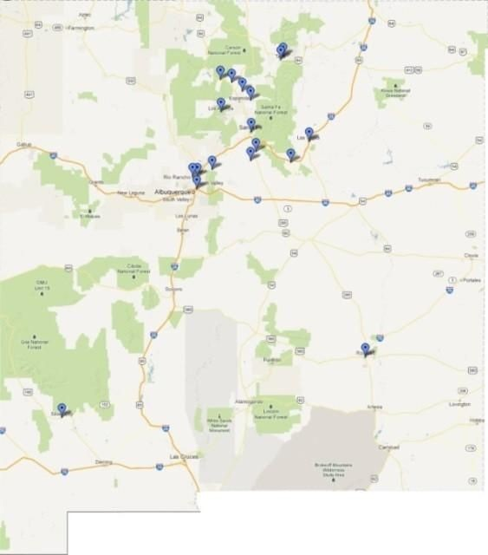

Classroom Loads/Sizes
The academic classroom loading policy varies but does not exceed statutory limits of 30:1 in any class with sizes varying between 10 and 30 students.

The arts programs vary by program:

Dance: varies from solo performance to large ensembles

Music: varies from 1-to-1 instruction to ensembles as large as 50

Theater: generally class sizes of 16

Visual Arts: generally class sizes of 16

Classroom Needs

Appendix B (Classes Needed) shows the derivation of academic classroom needs based upon projected student enrollment by grade level.

This spreadsheet is a helpful management tool for illustrating the importance of enrollment management and the fallacy of simply dividing enrollment by class size to determine the number of classrooms.

Based upon a maximum class size of 30, there can be 8 regular classrooms needed if there are 200 students in the school with 50 in each grade. But, if there are 204 students, there can be 10 classrooms needed given the same constraints.

Based upon judgment and practical sense, 10 regular classrooms and 2 science labs are needed for the 300 charter capacity.

Site and Facilities

Current Location
The former Sanbusco Center, now the new home of NMSA, is located at 500 Montezuma Ave in Santa Fe.
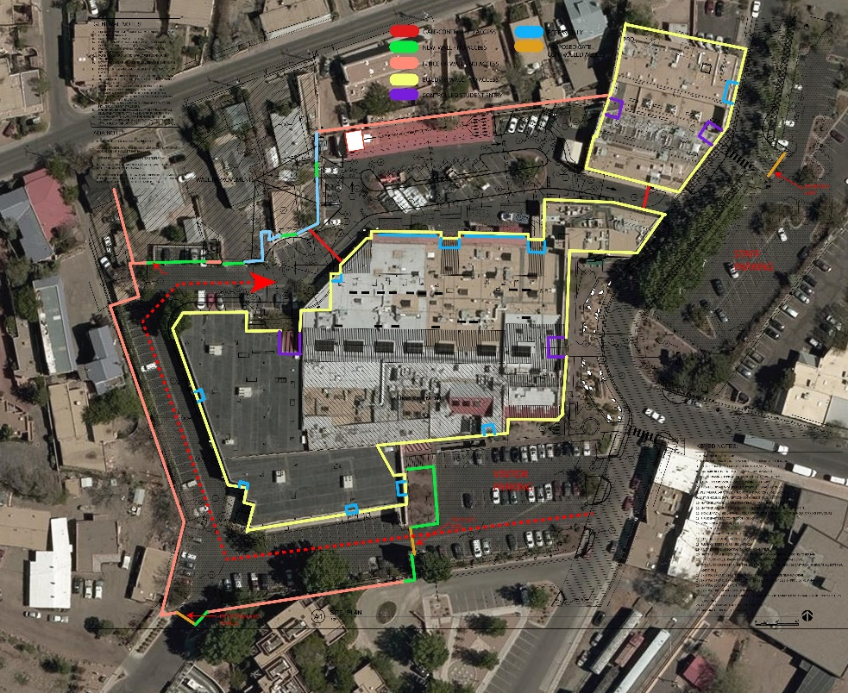

Current Site
The map above is an aerial view of the campus. The peach color outlines the perimeter of the site and is secured with a site wall. The parking area outside the peach color line is visitor and overflow parking.
The red dashed line indicates student drop-off and pick-up as outlined in the conditions for change of use by the city of Santa Fe.

Staff and visitor traffic enters and exits on Montezuma Ave.

Student drop-off traffic enters from Montezuma and proceeds in the direction of the red arrow along a through-lane into a drop-off area at the round-a-bout. This traffic then loops around a parent drop and exits through a gate back onto Montezuma. Traffic calming signs and bumps are being utilized.

Statewide Adequacy Standards

New Mexico’s statewide adequacy standards (NMAC 6.27.30) provide standards for public school districts to “…provide and sustain the environment to meet the needs of public schools.” They are intended to create a minimum facility standard to establish equity among all educational facilities serving New Mexico public school students. Charter schools are permitted to seek a variance for facilities, since they do not necessarily conform to the programs, delivery methods, and facility needs and budgets on which these standards are based. In such cases, schools meet the intent of the facility requirements through “alternative methods.” However, alternative and charter schools are required to provide the minimum square footage allowances for general classroom spaces, as identified in the adequacy standards.

Utilization and Capacity

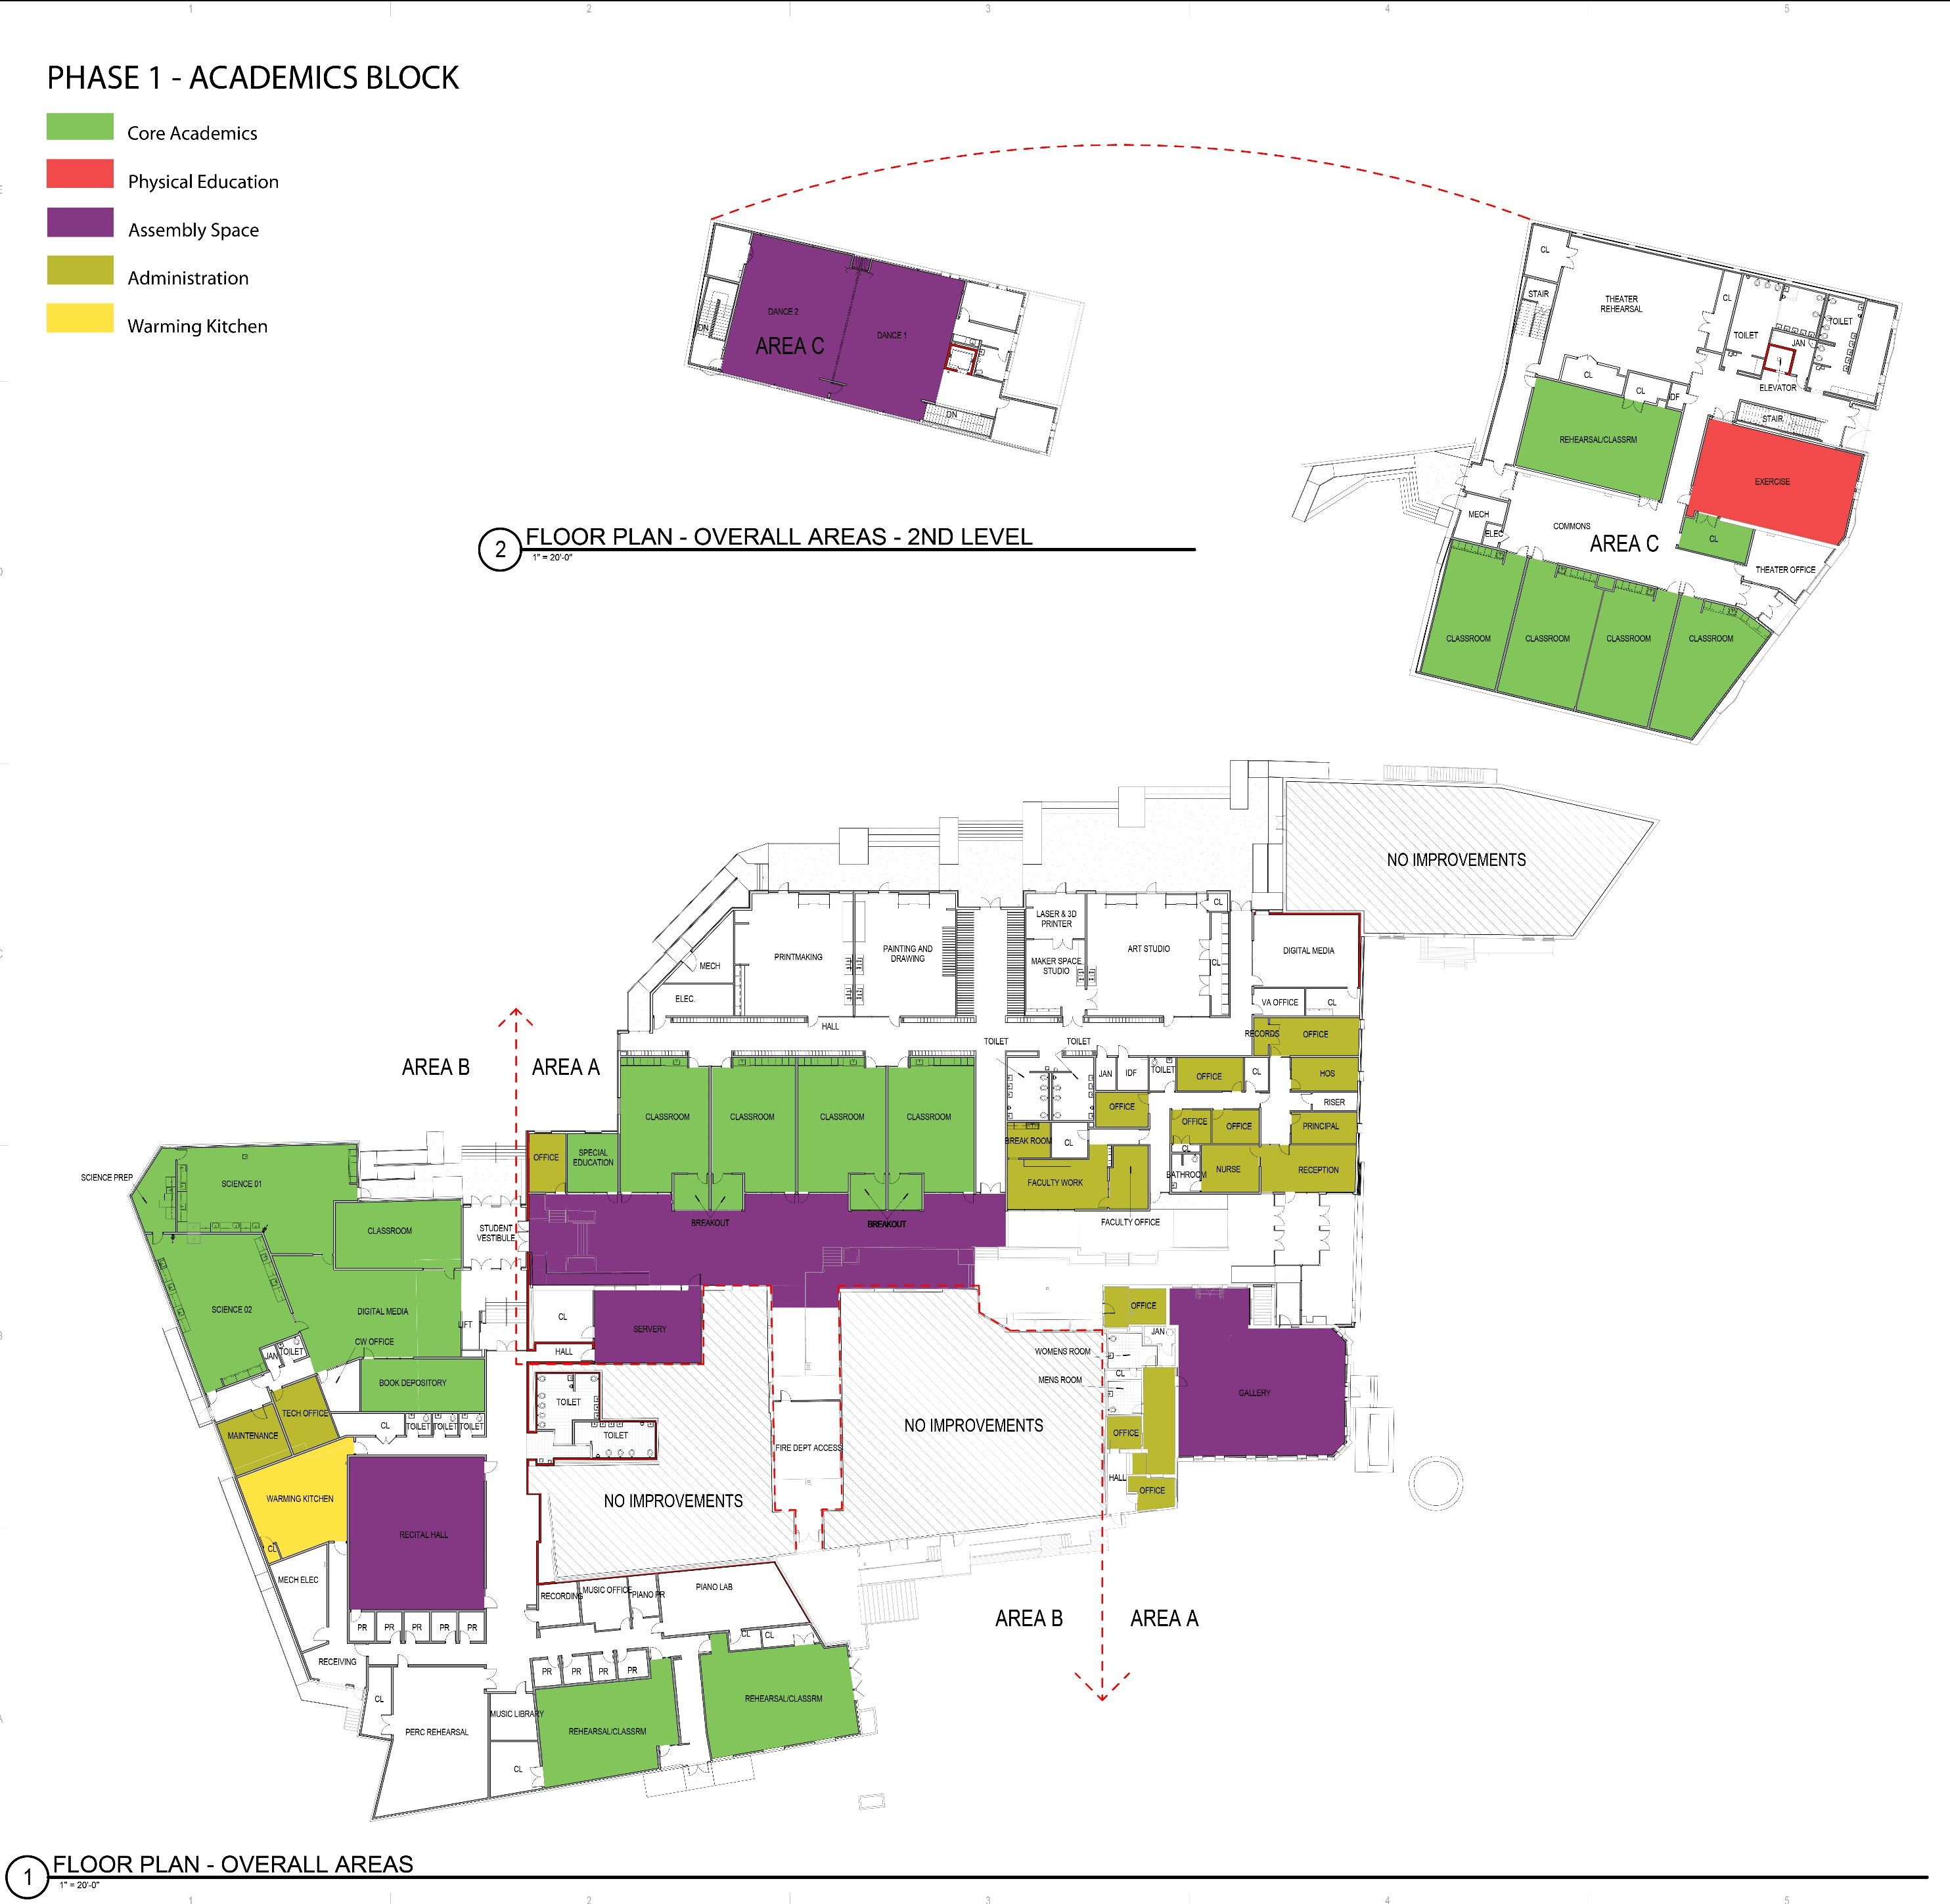

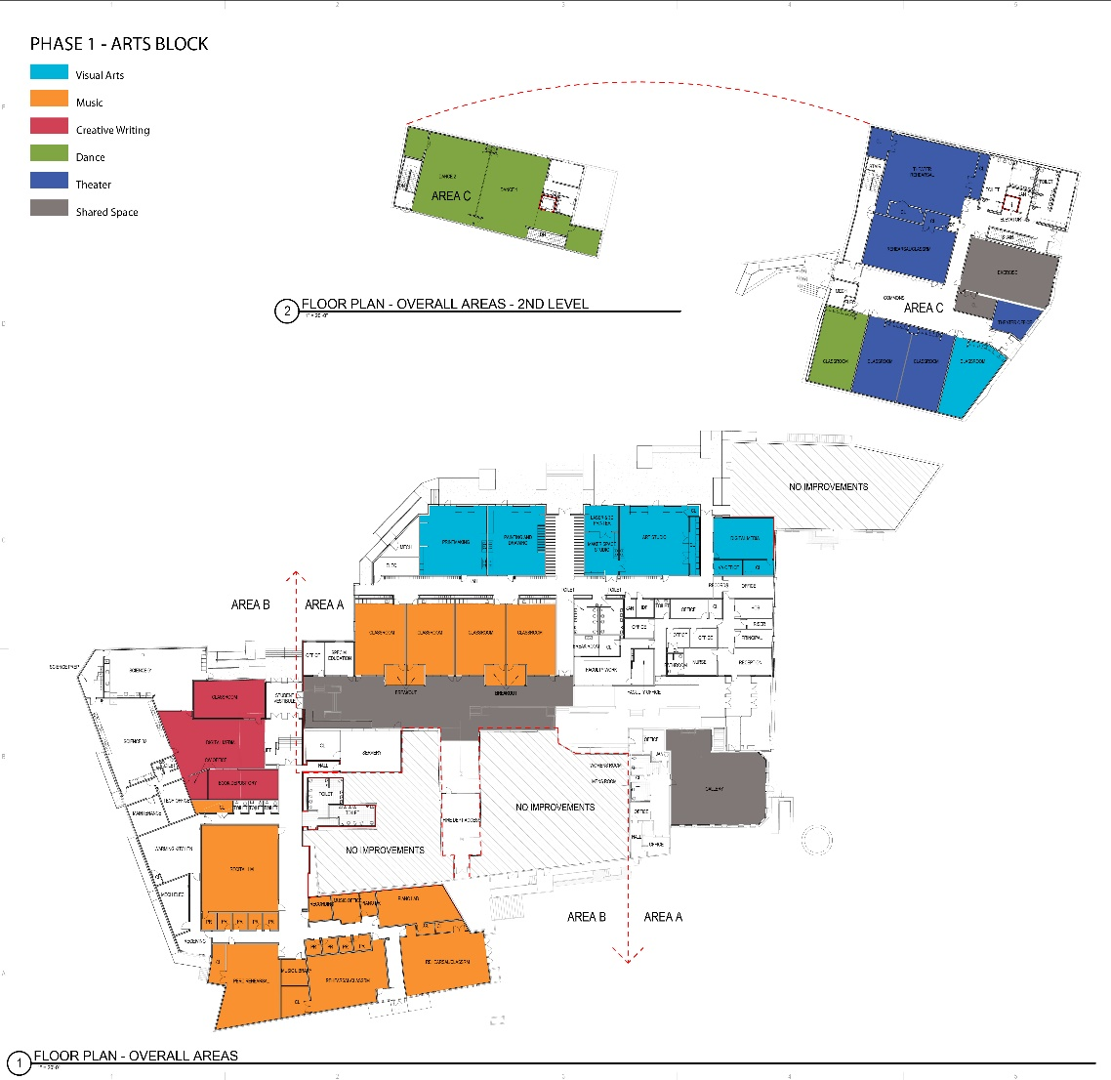

Utilization: Identify special factors that influence facility use.
The demands of the mastery arts program influence facility use in multiple ways:

      - Dedicated spaces, like “wet” visual arts areas for painting and sculpture, limit other uses for those spaces.
      - Accommodating long arts blocks at the end day limits students scheduling flexibility. A better solution to scheduling has yet to be found.
      - Teacher work space as classrooms are duel use (Arts and Academics).

Technology – Overview of Tech plan and needed equipment
NMSA’s approved Technology Plan is summarized below.
The technology vision is: “All our students learning today for tomorrow - NMSA students will have the technology skills needed to be successful in the world in which they will live and work.”

Technology Mission Statement: NMSA believes:
- Technology can be a tool to enhance our teaching technique and a means for modernizing our approach to academic and mastery arts education.
- Advanced technology will allow us to redefine the curriculum itself and allow us to integrate curriculum across subject areas.
- Technology can provide a bridge between academics and the arts. For example, the physics of light could be explored through photography and three-dimensional imaging or polarization. By combining traditional subjects with what our students are passionate about, we hope to motivate students to participate fully in their own academic growth.
- Using and understanding technology will allow students to become critical thinkers who use technology now to understand and shape their world.
- Students must understand the ethical use of social networking sites in order to join the global discussion by presenting their own artwork and ideas. Technology can provide students with an unprecedented medium for expression and communication.

NMSA’s long-term strategy is to move from a total time-based, presence-required mode of education to a blended learning model that frees students and teachers from some of the time and geographical constraints. NMSA also host its own LMS allowing students anytime access to most of their class content from anywhere. This may have significant facility implications.

Technology concerns for new facility:
- Power – plenty of outlets for recharging in classrooms (floor plugs by desks which eliminate extension cord hazard) and common areas. Capacity to wire the whole facility. (Media Arts needs in-house capacity and infrastructure to handle their large bandwidth and storage requirements. Two locations are needed for backup – the second space can be small.
- Theater and Dance performance space has very high electrical demand for lighting and technical support.

FACILITY REQUIREMENTS
  - Facility Goals and Concepts

Facility Goals

      - Create physical spaces to meet the program requirements for 300 plus students.
      - Create physical spaces that allow accomplished artists to offer
pre-professional instruction in creative writing, dance, digital media arts, music, theater, and visual arts.
      - Provide dormitory space for 60 students.
      - Locate in Santa Fe to take advantage of artistic resources.
      - Locate near public transportation services to meet statewide mandate.
      - Support a learning environment that emphasizes collaboration, interactive learning and creative problem solving.
      - Balance the need to meet New Mexico Adequacy Standards for public schools with the goals above along with the charge for charter schools to be innovative.
NMSA’s original charter was approved in 2008, re-approved in 2013, and renewed in 2018. One of our top priorities is to move the School into a permanent location. To date, NMSA has explored over 18 potential properties. It is NMSA’s goad to be in a permanent location by 2019 in accordance with statute 22-8B-4.2.

NMSA has a Building committee which meets regularly to ensure that the move to the Sanbusco site is on track for SY 2019-20 . The Building Committee has successfully:
- Found an available property that meets space and location needs,
- Professionally explored and gathered detailed information regarding location and acquired a property
- Determined what requirements NMSA must meet to be in compliance with NM PED with respect to a new location,
- Secured and PSFA approved Ed Specs Plan.
- Created a plan that not only includes a lease purchase agreement, projected maintenance for years to come, but also indirect costs associated with a new location such as need for increased security, transportation, equipment and furniture, etc.
- Construction

Concepts

      - Provide flexible spaces to permit student collaboration. This includes dedicated small spaces.
      - Anticipate increasing role of technology as well as blended learning.
      - Anticipate a move toward competency/mastery-based education model.
      - Create a building that is energy efficient, low on maintenance and efficiently utilized.

Space Requirements

Space Summary

In order to show the alternative means of providing efficiencies of tax dollar use, the space needs are broken down into two sections. Section A shows the space requirement for the Academic Program and Section B shows the space requirement for the Arts Program:

Section A: Academic Program Summary

300 Students (charter max.)
 | Square Footage
Academic | 12,590
Physical Education | 7,600
Cafeteria | 5,430
Admin. And Counseling | 1,380
Parent Workspace | 150
Gen. Storage | 300
Commons (above adequacy) | 1,900
Subtotal | 29,350
TARE 28% | 8,218
Total Academic | 37,568

The relationship between the Commons, Phys. Ed., and the Dance program needs further study and depends upon the ultimate selection of a facility. The Cafeteria and a Dining Space for Residential Students needs further study.

Detail for the above is in Appendix D.

Section B: Arts Program Space Summary – with goal to provide through alternative means.

 | Square Footage
Dance | 9,910
Music | 7,020
Theater | 8,696
Visual Arts | 5,850
Creative Writing | 900

Media Arts | 900
Subtotal | 33,276
TARE 28% | 9,317
Total Arts | 42,593

Residential (60 students)
 | Square Footage
Residential Area | 10,000
TARE 28% | 2,800
Total Residential | 12,800

Detailed support for the above is in Appendix E.

There are potential shared economies by using academic space for Music depending on location of facilities. Music requires a large number of individual practice spaces. Creative Writing & Literature and Cinematic Media Arts can be in academic spaces as well.

Site Requirements

Adequacy standards call for the following:

300 Students
Site
Parking 1.5 spaces/staff 30,38 45
Parking 1 space/four HS 75
Secure (fence/drop off/flow) Multipurpose play surface

Space Needs
Appendix D and Appendix E provide a detailed analysis of space needs that support Section 3.2.1

Implementation of Space Needs
The statewide mandate of the school which has a residential component and mastery arts component makes implementation of space needs particularly complex compared to other charter schools, as do financial constraints, which all schools share.

Here are major considerations/alternatives which can affect implementation:
- The current lease at St. Francis School, with options, will allow that facility to be used through July 2019, with an option for a one-year extension to July 2020. This lease can be ended, with notice by April 1, 2019. With the 212 student enrollment and requirements of mastery art space, this facility is at its capacity.
- Obtaining space away from the School for more of the mastery arts program, as is being done currently for Dance, can free up space for the academic program. However, downtown Santa Fe space is expensive to rent. Modular classrooms for the existing historical district site have approval hurdles and implementation would be expensive given the eventual move of the School. It should also be kept in mind that some students travel daily from Albuquerque and other distant locations. Adding an additional commute from St. Francis to another location compounds their daily travel time. Multiple locations also make supervision more difficult, particularly for emergencies.
- The location of the residential component is another variable the school needs to consider, particularly if students have to travel to and from the school.

Scenarios for Implementation – identify phasing strategies for meeting required needs with projected growth.

The Art Institute had purchased and has begun construction on a location that will accommodate both the academic and arts mastery programs.

CAPITAL PLAN
  - Capital Funding

Historic and Current Funding
Beginning its first operating year, NMSA-Charter School has received lease assistance from the PSCOC Lease Assistance program. This grant is applied for annually and the amount funded cannot not exceed the annual lease payments for classroom space; or $700 multiplied by the MEM of the prior year. The rate is indexed and currently
$733.

Fiscal Year | Fiscal Year Lease  Expense | PSCOC  Lease Assistance | Local Share paid through  SEG
7/1/10-6/30/11 | $150,000 | $95,279 | $54,721
7/1/11-6/30/12 | $150,000 | $95,702 | $54,298
7/1/12-6/30/13 | $150,000 | $129,803 | $20,197
7/1/13-6/30/14 | $150,000 | $137,631 | $12,369
7/1/14-6/30/15 | $150,000 | $148,730 | $1,270
7/1/15-6/30/16 | $150,000 | $143,937 | $6063
7/1/16-6/30/17 | $185,500 | $152,036 | $33,464
7/1/17-6/30/18 | $185,500 | $150,885 | $34,615
7/1/18-6/30/19  FINAL ALLOCATIONS NOT AVAILABLE We  have been advised of a possible 20% decrease | $188,375 | Between and  $120,000  and  $150,885  Estimates | $68,375 and  $37,490  Estimates

    - Current Capital Expenses
Since NMSA leases its facility from a non-public entity, it is prohibited from making capital improvements to the facility. The facility was built in 1948 and its age is showing. The school is receiving SB-9 funding that is being used for technology equipment. The annual amount is approximately $150,000.

Lease term and Expense: The original $150,000 annual lease for St. Francis Cathedral School ended on July 31, 2014. NMSA obtained an options to extend the lease, currently through July 31, 2019, with an option for another one-year extension through July 31, 2020, with the right to terminate with 120 day notice. The rent will increase to $188,374.00 annually for 2018-19. At the time of this update, the PSCOC had not allocated lease reimbursements for 2018-2019.

Potential Future Sources of Revenue
Much of the material in this section is drawn from NMPED Capital Outlay Bureau 2013 Reference Data Report.
There are three general sources of funding for public school capital projects in New Mexico:

- Direct Legislative Appropriations.
- Standards Based Process under the Public School Capital Outlay Act.
- Locally based revenues. Districts can generate revenue from the sale of bond, direct tax levies, earnings from investments, rents and sales of real property and equipment.

Direct Legislative Appropriations:
Direct Legislative Appropriations for capital outlay project funding are targeted for specific projects within the school district. Specific legislators sponsor these projects and are funded by the general fund or proceeds of the sale of severance tax bonds.
NMSA received two separate severance bond appropriations for planning, designing and building a new site.

Standards Based – Public School Capital Outlay Act.
This standards based funding mechanism is administered through the Public School Facilities Authority, the staff of the Public School Capital Outlay Council. It uses a statewide database which ranks the condition of every school building relative to statewide adequacy standards. The schools with the greatest needs will be addressed first; however, local participation is required. State charters’ percentage of participation is that of the district they are in. Santa Fe is one of the districts with the highest local share, 90%. For comparison, the local share of Albuquerque is

46%, Los Alamos 61% and Socorro 25%. There are also offsets for Direct Appropriations for projects.
The provisions of this act are complex.

According to the NMPED Capital Outlay Bureau 2012 Reference Data Report, if the PSCOC determines that the state-charter school does not have the resources to pay all or a portion of the total cost of the capital outlay project that is not funded with grant assistance from the fund, to the extent that money is available in the charter school capital outlay fund, the council shall make an award from that fund for the remaining amount necessary to pay for the project. The council may establish, by rule, a procedure for determining the amount of resources available to the charter school and the amount needed from the charter school capital outlay fund.

Locally Based Revenues:
Public School Buildings Act (HB33): This act allows districts to impose a tax not to exceed 10- mills for a maximum of six years on the net taxable value of property upon approval of qualified voters. In the Act, "Capital Improvements" means expenditures, including payments made with respect to lease-purchase arrangements as defined by the Educational Technology Equipment Act (6-15A-1). It excludes debt service expenses. After July 1, 2007, a resolution submitted to the qualifying electors pursuant to Subsection A of 22-26-3 NMSA 1978 shall include capital improvements funding for a locally or state-chartered charter school located within the school district if:
  - the school provides timely information regarding the capital improvements for which the revenue will be used and
  - the capital improvements are included in the districts five-year facilities plan. NMSA would be eligible for the ratio of its MEM to the total Santa Fe MEM.

The Public School Capital Improvements Act (SB-9 or the “two-mill levy”):
The district can ask local voters to approve levy of up to 2 mills for maximum of six years. NMSA has been included in Santa Fe’s elections and based on its MEM currently receives approximately funding. These funds cannot be used for debt service expenses (see lease purchase provision) but can be used to:

  - Erect, remodel, make additions to or provide equipment for public school buildings.
  - Purchasing or improving public school grounds.
  - Maintenance.
  - Purchase activity vehicles for transporting students to extracurricular activities.
  - Purchase computer software and hardware for student use in public school classrooms.

Capital improvements can only be made on a public building. Since NMSA is not currently in a public building, these capital funds cannot be used to improve the building. Consequently, for the February 2012 election, NMSA specified that the funds are to be used to purchase computer software and hardware for student use in public school classrooms.

Educational Technology Note:
The district can ask local voters to approve a levy for the specific purposes of provisioning schools with technology. NMSA has been included in Santa Fe’s elections and based on its MEM currently receives funding to purchase technology products and/or services.

Local General Obligation Bonds: DOES NOT APPLY
STATE CHARTER SCHOOLS ARE EXINCLUDED FROM THIS REVENUE STREAM
NMSA 22-18-1 says that general obligation bonds can be used for erecting, remodeling, making additions and furnishing, or purchasing or improving grounds. Also, they can provide matching funds for capital outlay projects funded pursuant to the Public School Capital Outlay Act (see below). It also says that the priorities for the school district’s capital needs as shown by the facility assessment database maintained by the public school facilities authority needs to be considered.
A district’s ability to sell bonds is limited to 6% of assessed valuation. There is a four-year period in which the bonds may be sold from a particular approved resolution.

The Public School Lease Purchase Act:
Although the Public School Lease Purchase Act is not a source of funds, it declares that a financing agreement by a charter for leasing a building or other real property

with an option to purchase for a price that is reduced according to the payments made pursuant to the financing agreement is not a debt if:
- There is no legal obligation for the charter school to continue the lease from year to year or to purchase the real property;
- The agreement provides that the lease shall be terminated if sufficient money is not available to meet the current lease payments.
The charter Emay apply any legally available funds to the payments.

Other: E-Rate: NMSA has participated in this program each year of operation. Based on free and reduced eligibility it is not entitled to capital funding, but NMSA does receive funding for approximately 50% of its telephone and internet service costs.

PSCOC Capital Outlay Funding (addressed above)

  - Capital Needs

The School’s capital needs are a permanent facility. After performing due diligence on seven sites (and considering a total of 18), the final site has been purchased, the planning has been completed, and construction of the new facility has begun.
The school has also been developing its programs (it received an “A” as its PED school grade in each of the last six years) and fundraising capacity.
Appendix H is a five-year capital plan outline that is partially completed. It breaks the capital needs of the School into three sections: Academic, Art and Residential and Residential Program. It specifies potential sources of revenue as well as needs. Once a site is selected an architectural firm will be employed to provide more specificity. There are too many variables to complete it at this time.

MASTER PLAN SUPPORT MATERIAL
  - Sites and Facilities Data Table
State identification number 509-001
Physical Address 275 E. Alameda St., Santa Fe, NM 87501

Date of Opening: August, 2010
Dates of major additions/renovations: DNA Facility Condition Index and NMCI NA Site owned or leased Leased Total building area gross sq/ft. 38,029
Site acreage 1.7 acres
Total number of permanent general classrooms 10

Total number of specialty classrooms 8 incl. Science, Mac Lab, Vis Arts Total number of portable classrooms 0 Total number of classrooms 18
Percentage portable classrooms to total: 0 Total enrollment current year (40th day) 221
Number of gross sq. ft. per student 172 (includes specialized art spaces for students)

Site Plan

Floor Plan – Scaled school floor plan with room numbers to match inventory See Appendix F1, F2, and F3.

  - Facility Inventory – Room use and square footage of each room. See Appendix G

  - Photographs (min 1 exterior and 1 interior)
  - Facility Evaluation
  - FAD Update
  - Detailed Space and Room Requirements (Ed Spec), if applicable
    - Technology and Communications Criteria

Network:
      - 200Mbps to 300Mbps download/upload capability would meet the needs of anticipated programs.
      - All offices, classrooms and common spaces should have network computer

access (Wi-Fi or Ethernet) for mobile laptops and sufficient electrical power in every classroom.
      - Instructional spaces shall have wireless network capacity to support 30 computers at least 54Mbps. See electrical section for electrical requirements.
      - Secure, air-conditioned server room centrally located within the building.
      - Secure closet with outside wall for communication line entrance from service providers.

Devices:
      - Each instructional space, office and support space will have at least two jacks capable of voice/data.
      - Each instructional space, student areas and office areas will have an intercom connection.
      - All instructional spaces and meeting rooms shall have projection capability and A/V screen.
      - Security cameras mounted on exterior door, parking areas and common areas, with two monitoring areas.

Power Criteria
Classrooms:
      - Minimum of 3 duplex outlets on every wall. To provide power to students at desks, additional overhead or floor outlets desired to avoid extension cords on floor as trip hazard.
      - Outlet for wall clock
      - Power for wall-mounted devices projection devices
      - Surge suppression
      - GFCI for science classrooms and any wet areas Offices and support spaces: Meet code for outlet distribution

Lighting and daylighting criteria
Day lighting of occupied spaces:
Provide exterior apertures to achieve a minimum glazing factor of at least 2% in all instructional spaces and a daylight illumination level of 25 foot candles, and in other occupied spaces as feasible. Glazing Factor = (Window Area /Floor Area x Window Geometry Factor x (Actual Tvis/Minimum Tvis) x Window Height Factor.

Classroom Lighting:
      - A light level of at least 50 foot candles is required at each instructional space, measured at a work surface located in the approximate center of the classroom, between clean light fixtures
      - All fixtures to have 2-level switching
      - Light fixtures in spaces of day lighting will have dimmable lamps controlled by occupancy sensors and photocells

Environmental Conditioning Criteria
Classroom Temperature:
      - Each general and specialty classroom shall have a heating, ventilation and air conditioning (HVAC) system capable of maintaining a temperature between 68 and 75 degrees Fahrenheit with full occupancy.
      - The temperature shall be measured at a work surface in the approximate center of the classroom.
Classroom Air Quality:
      - Each classroom shall have an HVAC system that continually moves air and is capable of maintaining a CO2 level of not more than 1,200 parts per million.
      - The air quality shall be measured at a work surface in the approximate center of the classroom.

Classroom Acoustics Criteria
      - The sound level of each general and specialty classroom shall be a one-hour, A-weighted Noise Criteria of less than 55 decibels
      - The sound level shall be measured at a work surface in the approximate center of the classroom
      - Reverberation times in the classroom shall be within a range of 0.4 – 0.6 seconds
      - All other occupied spaces shall maintain a background sound level of less than 55 decibels

Furnishing and Equipment Criteria
Each classroom shall have the following furniture:
      - Student work surfaces to accommodate 30 students, teacher’s desk, chair and file cabinet, whiteboards, etc.

      - Chairs need to be comfortable, durable and movable.
      - Tables should have durable surfaces and be movable for a variety of group configurations.

Table types
The following three table types are in current use at the School and provide flexibility to meet many needs.

Type 1 has a plastic top and seats two students on either side. It is used in the cafeteria and various classrooms. The work surface measures 6 feet by 2.5 feet. It is light and easily movable.

Type 2 has a laminate top and seats two students. The legs are on the outside. They are easily moved to a large rectangle where students can see all of the other students and can be moved to create groups of 4. The work surface measures 5 feet by 2 feet.
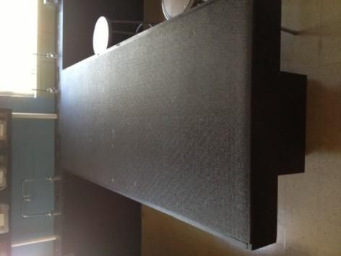

Type 3 is in the science lab. It was built in-house. It has a Chemguard top surface and storage as part of the inner pillar. Note that there are no perimeter legs so

students can easily draw their stools close. At the end of the table is gas service and sink. They measure 8 feet by 38in.

Storage types
Classrooms shall have upper and lower cabinets with work counter.

Criteria Sheets – provide as appropriate to support space recommendations

NAME OF SPACE: General Classrooms
Program: | Instruction
Number of Occupants: | 26- 30 students and instructor
ACTIVITIES AND FUNCTION:
Educational | Student Instruction Area
Operational Community | Flexible space for multiple subjects and seating arrangements  Possible meeting, music practice, creative writing space
FUNCTIONAL ADJACENCY REQUIREMENTS:
Direct Access
Indirect/Near | Other classrooms
Not Adjacent/Separate | Phys Ed, Kitchen, Loading Areas
ENVIRONMENT:
Temperature | 70-78
Acoustic | Acoustic separation from common/assembly space
Lighting | Natural lighting desired; non-glared, 50-70fc across space
HVAC | AC + natural ventilation desired
Aesthetic | studio - instructional, conducive to instruction and group work
FURNISHINGS/INSTRUCTIONAL
AIDS:
Marker Boards/Tackable Surfaces | Marker Boards and Tackable Surfaces
Movable Furniture | 26 - 30 student chairs, movable 2 person tables, teacher desk/chair
Projection Surfaces | Projection Whiteboard (Smart board)
Storage | Lockable - closet preferred
Cabinetry
Equipment | Wall mounted projection

INTERIOR FINISHES:
Flooring | Hard surface with carpet tile
Walls | 9'-0" min; painted finish
Ceiling | Acoustical Tile
WINDOWS: |  | Operable? | Shades?
Exterior |  | Yes | Yes
Interior |  | in door | Yes
TECHNOLOGY:
Voice | Telephone; handset w/intercom
Data | LAN access; wireless
Audio/Visual | NEC Wall mounted projector or equivalent
Clock/Intercom | Standard Clock, Intercom
Security | Lockable Door with View Panel
Fire Alarm | Smoke detector as required by Code
SPECIAL NOTES:
NAME OF SPACE: Science Classrooms
Program: | Instruction
Number of Occupants: | 16 - 30 students and instructor
ACTIVITIES AND FUNCTION:
Educational | Student Instruction Area
Operational  Community | Instruction and science experiments
FUNCTIONAL ADJACENCY REQUIREMENTS:
Direct Access | Prep room in between two science classrooms
Indirect/Near
Not Adjacent/Separate
ENVIRONMENT:
Temperature | 70-78
Acoustic | Acoustic separation from common/assembly space
Lighting | Natural lighting desired; non-glared, 50-70fc across space
HVAC | Natural ventilation desired, separate AC, air ducts
Aesthetic | Scientific, safe
FURNISHINGS/INSTRUCTIONAL
AIDS:
Marker Boards/Tackable Surfaces | Marker Boards and Tackable Surfaces
Movable Furniture | 30 stud chairs,2 person tables, teacher desk, see notes below
Projection Surfaces | Projection Whiteboard

Storage | Lockable - closet preferred
Cabinetry | Storage base cabinets lab tables
Equipment | Wall mounted projection
INTERIOR FINISHES:
Flooring | Hard surface
Walls | 9'-0" min; painted finish

Ceiling | Acoustical Tile
WINDOWS: |  | Operable? | Shades?
Exterior |  | Yes | Yes
Interior |  | in door | No
TECHNOLOGY:
Voice | Telephone; handset w/intercom
Data | LAN access; wireless
Audio/Visual | TV Video Input (jack)
Clock/Intercom | Standard Clock, Intercom
Security | Lockable Door with View Panel
Fire Alarm | Smoke detector as required by Code
SPECIAL NOTES:
7 lab tables 8' x 38" plus sink at end (chemical traps) and natural gas access. Safety shower/eyewash

NAME OF SPACE: Tech Lab and Media Arts
Program: | Instruction
Number of Occupants:
ACTIVITIES AND FUNCTION:
Educational
Operational
Community
FUNCTIONAL ADJACENCY REQUIREMENTS:
Direct Access | IT Office with workbench & storage
Indirect/Near
Not Adjacent/Separate
ENVIRONMENT:
Temperature | 66-72 Note: Cooler than classrooms
Acoustic | Acoustic separation from common/assembly

 | space
Lighting | Natural lighting desired; non-glared, 50-70fc across  space
HVAC | AC only. High AC load.
Aesthetic
FURNISHINGS/INSTRUCTIONAL AIDS:
Marker Boards/Tackable Surfaces | Marker Boards and Tackable Surfaces
Movable Furniture | 26 student chairs, movable 2 person tables
Projection Surfaces | Projection Whiteboard
Storage | Lockable - closet preferred
Cabinetry
Equipment | Wall mounted projection
INTERIOR FINISHES:
Flooring | Hard surface with carpet tile
Walls | 9'-0" min; painted finish

Ceiling | Acoustical Tile
WINDOWS: |  | Operable? | Shades?
Exterior |  | Yes | Yes
Interior |  | in door | Yes
TECHNOLOGY:
Voice | Telephone; handset w/intercom
Data | LAN access; wireless
Audio/Visual | TV Video Input (jack)
Clock/Intercom | Standard Clock, Intercom
Security | Lockable Door with View Panel
Fire Alarm | Smoke detector as required by Code
SPECIAL NOTES:
Adjacent IT Office with workbench and storage.

NAME OF SPACE: Faculty Workroom
Program: | Instructional Support
Number of Occupants: | Varies
ACTIVITIES AND FUNCTION:
Educational
Operational
Community

FUNCTIONAL ADJACENCY REQUIREMENTS:
Direct Access | Small room next to the Head of School office, off main corridor
Indirect/Near
Not Adjacent/Separate
ENVIRONMENT:
Temperature | 70-78
Acoustic | Acoustic separation from common/assembly space
Lighting | Natural lighting desired; non-glared, 50-70fc across space
HVAC | AC + natural ventilation desired
Aesthetic
FURNISHINGS/INSTRUCTIONAL
AIDS:
Marker Boards/Tackable Surfaces | Marker Boards and Tackable Surfaces
Movable Furniture | Tables and chairs for eating/working
Projection Surfaces
Storage | Lockable - closet preferred
Cabinetry
Equipment
INTERIOR FINISHES:
Flooring | Hard surface with carpet tile

Walls | 9'-0" min; painted finish
Ceiling | Acoustical Tile
WINDOWS: |  | Operable? | Shades?
Exterior |  | Yes | Yes
Interior |  | in door | No
TECHNOLOGY:
Voice | Telephone; handset w/intercom
Data | LAN access; wireless
Audio/Visual | TV Video Input (jack)
Clock/Intercom | Standard Clock, Intercom
Security | Lockable Door with View Panel
Fire Alarm | Smoke detector as required by Code
SPECIAL NOTES:
Open mail-boxes, fridge, microwave, toaster oven.

NAME OF SPACE: Administrative Office Space
Program: | Administration

Number of Occupants: | 3
ACTIVITIES AND FUNCTION:
Educational
Operational
Community
FUNCTIONAL ADJACENCY REQUIREMENTS:
Direct Access | Administration
Indirect/Near
Not Adjacent/Separate
ENVIRONMENT:
Temperature | 70-78
Acoustic | Acoustic separation from common/assembly space
Lighting | Natural lighting desired; non-glared, 50-70fc across space
HVAC | AC + natural ventilation desired
Aesthetic | Professional
FURNISHINGS/INSTRUCTIONAL
AIDS:
Marker Boards/Tackable Surfaces | Marker Boards and Tackable Surfaces
Movable Furniture | 26 student chairs, movable 2 person tables
Projection Surfaces | Projection Whiteboard
Storage | Lockable - closet preferred
Cabinetry
Equipment
INTERIOR FINISHES:
Flooring | Carpet

Walls | 9'-0" min; painted finish
Ceiling | Acoustical Tile
WINDOWS: |  | Operable? | Shades?
Exterior |  | Yes | Yes
Interior |  | in door | Yes
TECHNOLOGY:
Voice | Telephone; handset w/intercom
Data | LAN access; wireless
Audio/Visual
Clock/Intercom | Standard Clock, Intercom
Security | Lockable Door with View Panel

Fire Alarm | Smoke detector as required by Code
SPECIAL NOTES:

NAME OF SPACE: Administrative Offices (Typical)
Program: | Administration/Student Support
Number of Occupants: | 3
ACTIVITIES AND FUNCTION:
Educational
Operational Community | School/Instruction Leadership, Parental Communication,  Interface with parents, students, IEP meetings
FUNCTIONAL ADJACENCY REQUIREMENTS:
Direct Access | Administrative Assistants
Indirect/Near | Conference Room, School Entrance
Not Adjacent/Separate
ENVIRONMENT:
Temperature | 70-78
Acoustic | Acoustic separation from common/assembly space
Lighting | Natural lighting desired; non-glared, 50-70fc across  space
HVAC | AC + natural ventilation desired
Aesthetic | Open and inviting
FURNISHINGS/INSTRUCTIONAL AIDS:
Marker Boards/Tackable Surfaces | Tackable Surface
Movable Furniture | 1 staff Desk; 3 guests
Projection Surfaces
Storage | Cabinets
Cabinetry | Fireproof file storage, 2 drawer and 4 drawer
Equipment | Computer, printer
INTERIOR FINISHES:
Flooring | Carpet

Walls | 9'-0" min; painted finish
Ceiling | Acoustical Tile

WINDOWS: |  | Operable? | Shades?
Exterior |  | Yes | Yes
Interior |  | in door | Yes
TECHNOLOGY:
Voice | Telephone; handset w/intercom
Data | LAN access; wireless
Audio/Visual
Clock/Intercom | Standard Clock, Intercom
Security | Lockable Door with View Panel
Fire Alarm | Smoke detector as required by Code
SPECIAL NOTES:
Office for security near reception if the School retains a
security officer.

NAME OF SPACE: Cafeteria/Kitchen
Program: | Student Support
Number of Occupants: | 221
ACTIVITIES AND FUNCTION:
Educational | Student Support
Operational
Community
FUNCTIONAL ADJACENCY REQUIREMENTS:
Direct Access | Loading dock or ramp
Indirect/Near
Not Adjacent/Separate
ENVIRONMENT:
Temperature | 70-78
Acoustic | Acoustic separation from classrooms, kitchen
Lighting | Natural lighting desired; non-glared, 50-70fc across space
HVAC | AC + natural ventilation desired. Kitchen well vented.
Aesthetic | Sanitary
FURNISHINGS/INSTRUCTIONAL
AIDS:
Marker Boards/Tackable Surfaces
Movable Furniture | Light weight plastic tables (Type 1)
Projection Surfaces | Projection screen for large groups. Ceiling mount.
Storage | Refrigeration, dry food storage, separate cleaning

 | supplies.
Cabinetry | Cash register at egress of serving area.
Equipment | Standard Clock, Intercom, Kitchen Equipment
INTERIOR FINISHES:
Flooring | Surface easily cleanable (vinyl tile cafeteria, sealed  kitchen)

Walls | 9'-0" min; painted finish
Ceiling | Acoustical Tile - Cafeteria Painted - Kitchen
WINDOWS: |  | Operable? | Shades?
Exterior |  | Yes | Yes
Interior
TECHNOLOGY:
Voice | Telephone; handset w/intercom
Data | LAN access; wireless
Audio/Visual
Clock/Intercom | Standard Clock, Intercom - loud enough to be heard - two
Security | Lockable Door with View Panel
Fire Alarm | Smoke detector as required by Code
SPECIAL NOTES:
Required for Federal School Lunch Program, Food Prep and storage regulated by State and Federal.

Storage for tables, floor drains kitchen, grease traps, fire suppression. Kitchen manager’s office.

Relation for residence food service yet to be determined. Investigating alternative means.

ACTIVITIES AND FUNCTION:
Educational | Phys Ed (may be provided through alt. means Dance)
Operational Community
FUNCTIONAL ADJACENCY REQUIREMENTS:
Direct Access | Storage, Bathrooms, Water fountain
Indirect/Near | Parking
Not Adjacent/Separate | Classrooms, Administrative Offices
ENVIRONMENT:

Temperature | 68-72
Acoustic
Lighting | Protected lighting desired; High windows.
HVAC | AC + natural ventilation desired
Aesthetic | Light, airy
FURNISHINGS/INSTRUCTIONAL
AIDS:
Marker Boards/Tackable Surfaces | Tackable Surfaces, Marker Board
Movable Furniture | Athletic equip.- Volleyball, basketball
Projection Surfaces
Storage | Lockable - closet preferred
Cabinetry
Equipment
INTERIOR FINISHES:
Flooring | Wood surface
Walls

Ceiling | Acoustical Tile
WINDOWS: |  | Operable? | Shades?
Exterior | High Windows | Yes | Yes
Interior |  | in door | No
TECHNOLOGY:
Voice | Telephone; handset w/intercom
Data | LAN access; wireless
Audio/Visual | TV Video Input (jack)
Clock/Intercom | Standard Clock, Intercom
Security | Lockable Door with View Panel
Fire Alarm | Smoke detector as required by Code
SPECIAL NOTES:
Full opening double doors Two locker rooms with showers and two offices. Lockers - more female than male.

NAME OF SPACE: Business Office
Program: | Administration

Number of Occupants: | 2 plus visitors area
ACTIVITIES AND FUNCTION:
Educational | Support
Operational Community | Accounting, Purchasing, Payroll, Personnel, Benefits,
FUNCTIONAL ADJACENCY REQUIREMENTS:
Direct Access
Indirect/Near
Not Adjacent/Separate
ENVIRONMENT:
Temperature | 70-78
Acoustic | Acoustic separation from common/assembly space
Lighting | Natural lighting desired; non-glared, 50-70fc across space
HVAC | AC + natural ventilation desired
Aesthetic | Office, Efficient Record Storage
FURNISHINGS/INSTRUCTIONAL
AIDS:
Marker Boards/Tackable Surfaces | Marker Board and Tackable Surface
Movable Furniture | 3 work spaces, space for visitor to fill out paperwork
Projection Surfaces
Storage | Lockable, Fireproof File Storage. Meet record keeping req.
Cabinetry
Equipment
INTERIOR FINISHES:
Flooring | Carpet

Walls | 9'-0" min; painted finish
Ceiling | Acoustical Tile
WINDOWS: |  | Operable? | Shades?
Exterior |  | Yes | Yes
Interior |  | N | No
TECHNOLOGY:
Voice | Telephone; handset w/intercom
Data | LAN access; wireless
Audio/Visual
Clock/Intercom

Security | Lockable Door with View Panel
Fire Alarm | Smoke detector as required by Code
SPECIAL NOTES:

Operational  Community | Maintenance Office, Custodial Supplies
FUNCTIONAL ADJACENCY REQUIREMENTS:
Direct Access | Major circulation - Janitorial
Indirect/Near | Support areas
Not Adjacent/Separate | Reception, entry
ENVIRONMENT:
Temperature | 70-78
Acoustic | Acoustic separation from common/assembly  space
Lighting | Natural lighting desired; non-glared, 50-70fc across  space
HVAC | Ventilated
Aesthetic | Organized storage area
FURNISHINGS/INSTRUCTIONAL AIDS:
Marker Boards/Tackable Surfaces | One tackable surface, white board in  maintenance
Movable Furniture | Open storage, metal shelving
Projection Surfaces
Storage | Open shelving,
Cabinetry | Wall mounted storage shelving, racks for mops, broom, vacuum
Equipment Chemical dispenser for cleaning supplies in janitorial
INTERIOR FINISHES:
Flooring | Hard surface
Walls | 9'-0" min; painted finish
Ceiling | Acoustical Tile

WINDOWS: |  | Operable? | Shades?

Exterior |  | No | No
Interior |  | No | No
TECHNOLOGY:
Voice | Voice Maintenance Desk
Data | LAN access Maintenance Desk
Audio/Visual
Clock/Intercom
Security | Lockable Door
Fire Alarm | Smoke detector as required by Code
SPECIAL NOTES:
Maintenance desk inside shop area for repairs.
Separate janitorial closets on each floor.Room on outside for snow shovels, lawnmower.

NAME OF SPACE: Health Office
Program: | Health
Number of Occupants: | 1 Staff Desk, student waiting, exam
ACTIVITIES AND FUNCTION:
Educational | Professional Office, Administrative
Operational Community | Health Screening, sick student care, medication disbursement  Interacts with community - parents
FUNCTIONAL ADJACENCY REQUIREMENTS:
Direct Access | Single Bathroom
Indirect/Near
Not Adjacent/Separate | Cafeteria
ENVIRONMENT:
Temperature | 70-78
Acoustic | Acoustic privacy
Lighting | Natural lighting desired; non-glared, 50-70fc across  space
HVAC | AC + natural ventilation desired
Aesthetic | Comforting, friendly, warm and cool colors
FURNISHINGS/INSTRUCTIONAL AIDS:
Marker Boards/Tackable Surfaces | Tackable Surface
Movable Furniture | Executive desk, staff chair, 3 guest chairs
Additional Furniture | 2 Student cots, ceiling mounted privacy curtain
Storage | File Storage, Lockable medicine cabinet
Cabinetry | Lockable countertop over base cabinets, overhead  cabinets
Equipment | Computer, Printer, Refrigerator

INTERIOR FINISHES:
Flooring | Hard surface
Walls | 9'-0" min; painted finish
Ceiling | Acoustical Tile
WINDOWS: |  | Operable? | Shades?
Exterior
Interior
TECHNOLOGY:
Voice | Telephone; handset w/intercom
Data | LAN access; wireless
Audio/Visual
Clock/Intercom | Standard Clock, Intercom
Security | Lockable Door
Fire Alarm | Smoke detector as required by Code
SPECIAL NOTES:

Ambulance access.

Capital Improvement Plan (CIP), if available.
Summary table of priority capital improvement for the next 5 years and project cost details. (See Appendix H)

Appendices

Appendix B – Classrooms Needed

Shows varying impact of enrollment on academic classroom needs.

 | Grade 9 | Grade 10 | Grade 11 | Grade 12 | Total
SY1011 | 54 | 46 | 35 | NA | 135
SY1112 | 45 | 60 | 48 | 30 | 183
SY1213 | 45 | 53 | 55 | 38 | 191
SY1314 | 53 | 54 | 47 | 47 | 201
SY1415 | 51 | 51 | 53 | 41 | 196
SY1516 | 60 | 56 | 49 | 45 | 210
SY1617 | 60 | 60 | 54 | 47 | 221
SY1718 | 58 | 55 | 58 | 51 | 222
SY1819 * | 55 | 56 | 50 | 50 | 211

Average Class Size =
English | 10 | 8 | 12 | 10 | 11 | 12 | 16
Math | 10 | 8 | 12 | 10 | 11 | 12 | 16
Science | 10 | 8 | 12 | 10 | 11 | 12 | 16
Social Studies | 10 | 8 | 12 | 10 | 11 | 12 | 16
Spanish | 10 | 8 | 12 | 10 | 11 | 12 | 16
Art - Provided by Arts
Program
Other (Health,Career) | 6 | 6 | 6 | 6 | 6 | 12 | 12
Total Classes Held. | 56 | 46 | 66 | 56 | 61 | 72 | 92
Classroom need/period - 6  PER | 10 | 8 | 11 | 10 | 11 | 12 | 16
Less Science | 1 | 2 | 2 | 2 | 2 | 2 | 2
General Classrooms - 6 PER | 9 | 6 | 9 | 8 | 9 | 10 | 14
Actual per utilization spreadsheet | 9

Appendix C: Utilization

NMSA uses 100% of the classroom, large rehearsal hall, cafeteria, foyer and common areas for both the academic and arts blocks. Students arrive for the academic day at 9:15 each day for a 9:20 start. Students move into the arts block beginning at 2:10 pm and finish at 4:45pm.

Appendix D. Space Needs (Academic and Arts

Academic Program (300 Students)
 | Square Footage
General Classrooms | 5,400
General Classroom Storage | 400
Science Classrooms | 2,400
Science Prep | 80
Special Education | 200

Media Arts | 1,800
IT Office/Storage | 260
Career Ed - Arts | 1,200
Faculty Workspace | 300
Administrative Space | 300
Subtotal | 12,420
Physical Education | 6,500
Dressing Rooms (x2) | 800
Offices (x2) | 300
Subtotal | 7,600
Dining | 2,400
Kitchen (HS 1,700 minimum) | 2,100
Serving | 700
Staff Restroom | 150
Office | 80
Subtotal | 5,430
Head of School’s Office | 150
Assistant Principal’s Office | 120
Dean of Students Office | 120
Additional Office (Counselor - Student Support) | 120
Reception/Administrative Support | 200
Conference | 200
Registrar | 120

Business Office (includes storage) | 350
Parent Workspace | 400
General Storage | 600
Commons | 2,000
Subtotal | 4,380
TARE (28%) | 8,330
Total | 38,080
Appendix E. Arts Program Space Needs

Arts Program (300 students)
 | Square Footage
Dance
Locker Rooms | 800
NDI Studio A (house 68 x 62) | 4,216
NDI Studio B (stage 68 x 42) | 2,856
Small Studio A (34 x 26) | 884
Small Studio B (40 x 30) 7 to 10 kids | 1,200
Department Head Office | 100
Staff Room | 154
Storage | 500
Subtotal | 10,710
Music
Choral Room with Risers | 1,000

Orchestra Practice Room | 1,200
Piano Lab Practice Room | 720
Large Music Teaching Studios (x3) | 1,200
Small Music Teaching Studios (x5) | 600
Individual Practice Rooms Wenger Lg & sm (x20) | 1,600
Office Department Chair | 100
Music Staff Room w/Music Library Space | 300
Subtotal | 6,720
Theater
Instruction | 750
Large Classrooms (32 x 32) x4 | 4,096
Dressing Rooms | 400
Make-up | 400
Department Chair | 100
Department Office | 150
Performance Space | 2,000
Storage (shared with dance) | 500
Lobby, Concessions | 300
Subtotal | 8,696
Visual Arts
Classrooms (1:16 classroom:students) x4 | 4,000
Storage x4 | 400
Department Chair Office | 100
Department Space | 150
Woodshop with Theater | 1,000

Artist in Residence Space | 200
Subtotal | 5,850
Creative Writing Classrooms | 900
Media Arts/Computer Lab | 900
Arts Total | 31,976
TARE (28%) | 8,953
Total Arts | 40,929
Residential | 10,000
TARE (28%) | 2,500
Residential Total | 12,500
Development Director | 150
Development Officer | 100
Expansion | 200
Assistant | 100
Research | 100
Conference | 300
Bathroom | 200
Kitchenette | 50
Storage | 50
Subtotal | 1,250
Total Art Institute | 54,679

 | 375 | 524
 | 3,060 | 22,617 | 910 | 8,586 | 2,952 | 6,893 | 6,458 | 100
 |  | 9,390 |  |  |  |  |  | 9,390

Appendix G. Facility Inventory
Ceramics/Visual Art English
Math
Music - Electronic Pianos Music – Chorale
Music (incl. large closet)
Science and Prep (Storage) Practice Rooms by Science Small Reher./Gp. Meetings Gym/Auditorium/Theater Stage Theater Office
Theater Storage Below Stage Painting
History, Sci., 9th Grade Academic Seminar Media Lab/Visual Arts
MacLab Social Studies/Language Language Social Studies
Visual Arts - 3 D lab.
Basement Music Practice Support Spaces Counseling/Dean of Students Faculty Work Space/Lounge Reception
Head of School Assistant Principal
School Record Storage Safe Registrar/IT small bathroom
Business Office incl. Storage Dance Office
Kitchen Prep Area/Freezer
Cafeteria
Practice Rooms/Storage NDI leased space for dance

Appendix H. Capital Outlay Revenue

New Mexico School for the Arts Projected Capital Resources for Building Purchase
June 2018
Fund | Initial Amount | Actual Expenditure s | Remaining Amount | Date Expires | Allowed Use | Note
Educational Technology - 31900
2015 | $29,581 | $1,272 | $28,309
2016 |  | $9,103 | $19,206
2017 | $152,935 | $24,975 | $147,166
2018 | $161,158 | $18,513 | $289,811
SB-9 - 31700 - State
(included local to FY2016)
2010
2011
2012 | $2,871 | $2,871 | $-
2013 | $160,739 | $66,228 | $94,511
2014 | $167,655 | $100,071 | $162,095
2015 | $158,529 | $74,039 | $244,486
2016 | $150,331 | $41,977 | $9,520
2016 | $- | $- | $352,839 |  |  | Cash balance re-classified to fund 31701

2017 | $5,274 | $9,520 | $5,274
2018 | $5,427 | $- | $10,701
SB-9 - 31701 - Local
2016 | $- |  | $-
2017 | $158,494 | $39,480 | $471,853 |  |  | Initial Amount is projected revenue.  Remaining Amount is current cash balance plus projected revenue.
2018 | $167,915 | $47,823 | $591,945
HB-33 - 31600
2010 |  | $-
2011 |  | $-
2012 |  | $-
2013 |  | $-
2014 |  | $-
2015 |  | $-
2016 | $106,554 | $1,066 | $105,489
2017 | $117,765 | $1,178 | $222,076
2018 | $125,904 | $2,621 | $345,359 |  |  | Initial Amount is projected revenue.  Remaining Amount is current cash

 |  |  |  |  |  | balance plus projected revenue.
Cap Outlay
Special Leg 14 | $210,000 | $- | $148,289 | 6/30/18
Special Leg 15 | $100,000 | $- | $100,000 | 6/30/18 |  | Needs to be renewed during the 2019 legis session
GO Bond Library
2010
2011
2012 | $5,118 | $5,118 | $- |  |  | Fund 27105 &  27106
2013 | $- | $- | $- |  |  | Fund 27105 &  27106
2014 | $3,216 | $- | $3,216
2015 | $3,216 | $- | $3,216
2016 | $6,744 | $3,216 | $3,528 | 6/30/17
2017 | $3,528 | $- | $3,528 | 6/30/17
2018 | $- | $- | $3,528 |  |  | Initial amount is prior year balance.  There is no current year allocation yet.

TO BE UPDATED IN THE NEXT REVISION OF THE FMP AS IT IS TIED TO THE NEW SITE

Residential Program | 2018-19 | 2019-20 | 2020-21 | 2021-22 | 2022-23
Obtain Site
Planning
Demolition/Sitework
Construction:
Private Funding | 2018-19 | 2019-20 | 2020-21 | 2021-22 | 2022-23
Foundations
Capital Gifts
Public Funding
Direct Legislative Appropriations
Public School Capital Outlay Act through PSCOC
Total

Submitted by C Montoya, 02.01.2019

